SPECIAL TOPICS IN INFORMATION SECURITY
Integrated Two-Device
Incident Response Lab
A safe and reproducible investigation across Ubuntu and Windows
Student | Ayham Al-Swaiti
Student ID | 12116003
University | An-Najah National University
Course | Special Topics in Information Security
Domain | Incident Response
supervisor | DR. Jehad Hamamreh
Authorized scope: The lab used two personal devices. It did not use malware, take advantage of a vulnerability, check public systems, or reach out to a real attacker address.

Executive Summary
This project shows a full incident response workflow on two physical devices. The analyst and server platform was Ubuntu 26.04 LTS. The monitored endpoint was Windows 11 pro. The investigation progressed from preparation and detection to collection, containment, analysis, correlation and recovery.
The situation had been made safe on purpose. It produced marked authentication, process, file and network with no malware or exploitation. When possible, evidence was collected before containment and then preserved with timestamps and SHA-256 hashes. You end up with a small but realistic lab that you can reproduce, review and explain to both an academic and a technical audience.
10  course skills | 2  physical devices | 4,210  timeline events | PASS  finalization

Key result | Observed value
Velociraptor collection | 336 process and network rows
Splunk detection | 12 simulated failed logins from one documentation address
Timesketch | 4,210 events; 99 tagged safe-simulation
Memory acquisition | Approximately 11 GiB; SHA-256 matched after transfer
Volatility 3 | Seven plugin outputs validated
Recovery | Deleted-file recovery and backup restore passed

Professional value: The lab demonstrates endpoint visibility, evidence handling, scoped containment, forensic analysis and recovery validation – the same control areas you would expect to see in a small security operations or incident response function.

1. Objectives and Scope
The project had four practical goals:
- Connect a Windows endpoint to an Ubuntu-based incident response platform.
- Collect host evidence prior to taking a narrow and reversible containment action.
- Correlate Linux, Windows, network, memory, and timeline evidence.
- Prove that evidence and backups remain usable through hashing and restore tests.
In scope | Out of scope
Two authorized physical devices | Public scanning or third-party systems
Synthetic authentication, process, file, and network markers | Malware, credential theft, persistence, or exploitation
Local and LAN administration | Internet-facing management interfaces
Hashed evidence and privacy-safe exports | Raw memory or secret configuration in the public package

The addresses 198.51.100.77 and 203.0.113.50 are part of the blocks reserved for documentation in RFC 5737 [9]. They were utilized only as simulation values and were never used as real network destinations.

2. Environment and Architecture
Component | Version or value | Role
Ubuntu analyst | Ubuntu 26.04 LTS; 16 GiB RAM | Collection, analysis, and evidence storage
Windows endpoint | Windows 11 Pro 25H2; 8 GiB RAM | Monitored endpoint and memory source
Velociraptor | 0.77.1 | Remote collection and endpoint visibility
Splunk | 10.4.2 | Log search, statistics, and dashboard
Timesketch | 20260630 | Timeline review
Volatility 3 | 2.28.0 | Windows memory analysis
Evidence root | /mnt/ir-evidence/incident-response-project | Case files and hashes

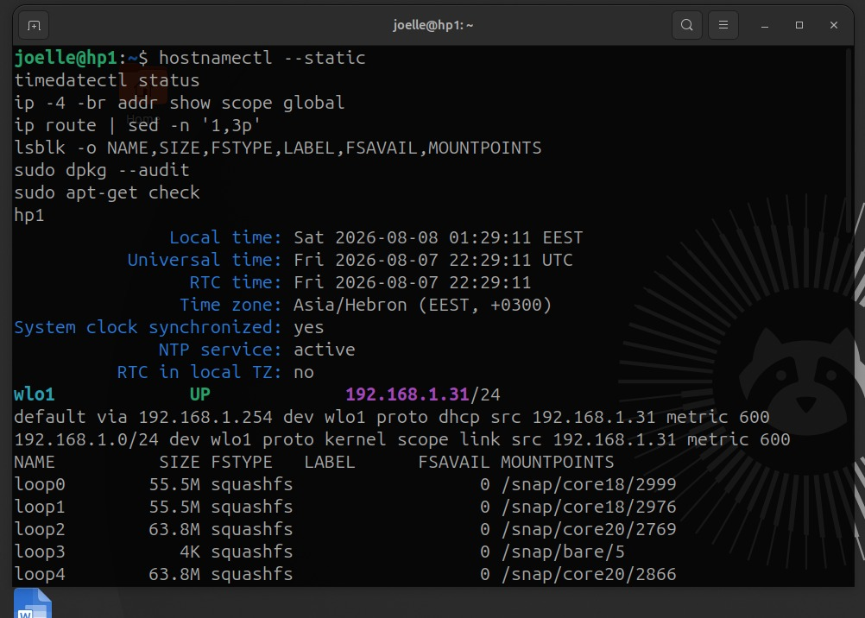
Figure 1. Ubuntu baseline showing synchronized time, LAN addressing, storage, and package checks.
Management interfaces stayed either local or on the private LAN. The Velociraptor GUI used 127.0.0.1:8889, while the Windows client talked to the Ubuntu frontend at 192.168.1.31:8000. Splunk and Timesketch were run only when absolutely necessary because both tools stress a 16 GiB laptop pretty hard.

3. Method and Ten-Skill Mapping
The process aligns with the evidence-aware incident response methodology from NIST SP 800-61 Rev. 3 [1] and the forensics integration recommendations in NIST SP 800-86 [2]. The practical sequence was:

Prepare -> Detect -> Collect -> Contain -> Analyze -> Correlate -> Recover
# | Exact skill name | Project evidence
1 | implementing-velociraptor-for-ir-collection | Remote Windows evidence
2 | analyzing-security-logs-with-splunk | Threshold search and dashboard
3 | analyzing-linux-audit-logs-for-intrusion | auditd evidence review
4 | collecting-volatile-evidence-from-compromised-host | Processes, sockets, sessions, and memory
5 | containing-active-breach | Narrow IOC-only containment and rollback
6 | conducting-memory-forensics-with-volatility | Seven Volatility 3 plugins
7 | performing-disk-forensics-investigation | Disposable image and deleted-file recovery
8 | collecting-indicators-of-compromise | Reviewed IOC register and STIX 2.1
9 | building-incident-timeline-with-timesketch | Chronological investigation
10 | validating-backup-integrity-for-recovery | Tamper detection and isolated restore

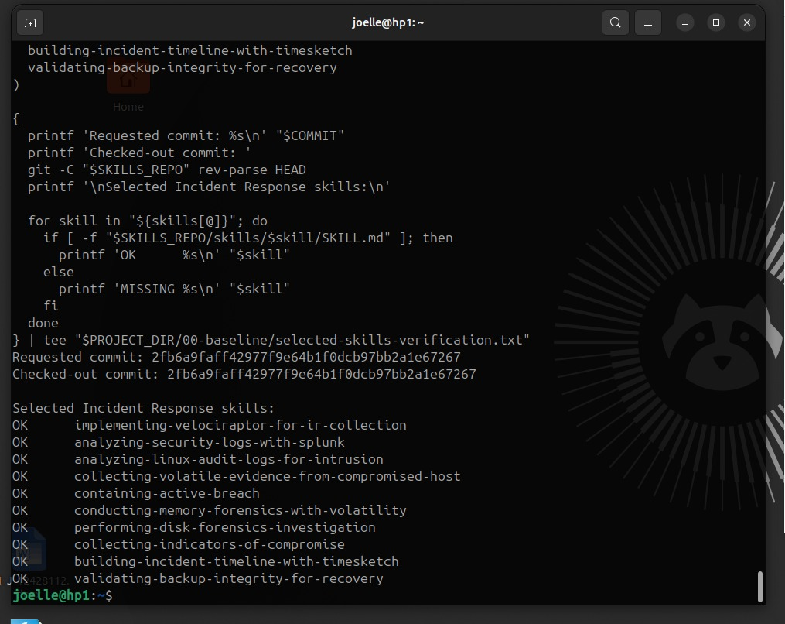
Figure 2. All ten exact skill paths verified at the course-pinned repository commit.

4. Endpoint Collection and Safe Containment
Velociraptor was picked since it works with endpoint artifacts, file extraction, forensic analysis, and server automation [3]. The Windows client finished enrolling correctly and stayed visible from Ubuntu.

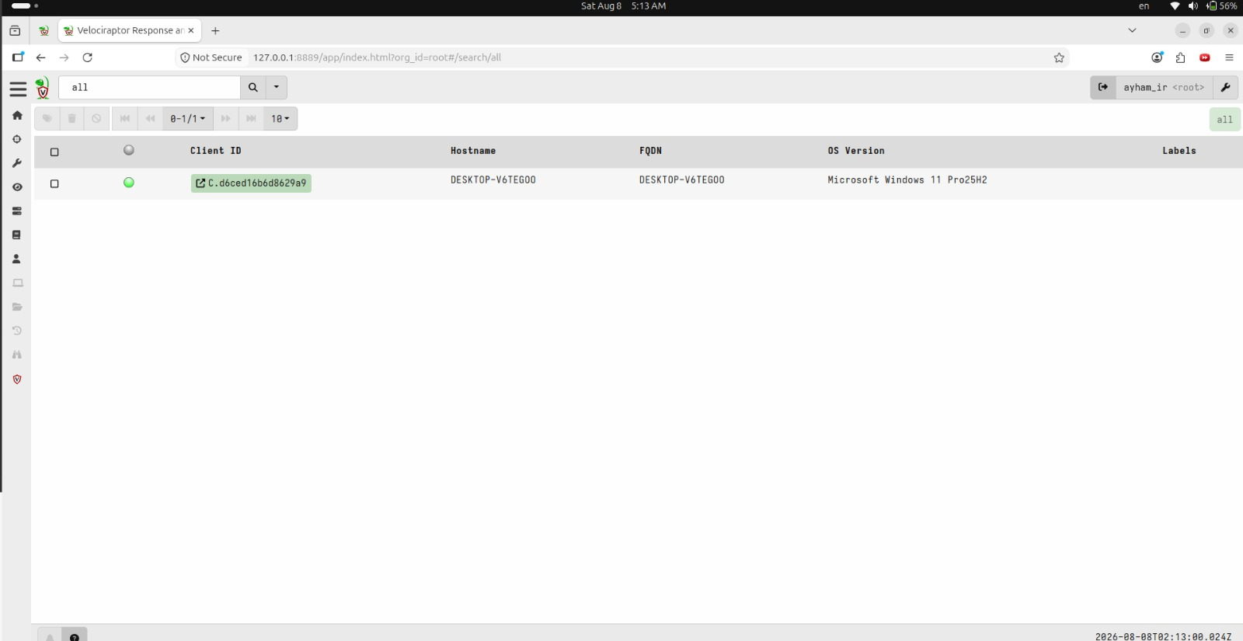
Figure 3. DESKTOP-V6TEGOO connected to the Ubuntu Velociraptor server.
We got two things from the computer: Generic.System.. Windows.Network.Netstat. These two things gave us 336 rows of information. The Generic.System.. Windows.Network.Netstat datasets are helpful because they show us how things are connected on the computer and what is going on with the network without doing anything that could hurt the computer.
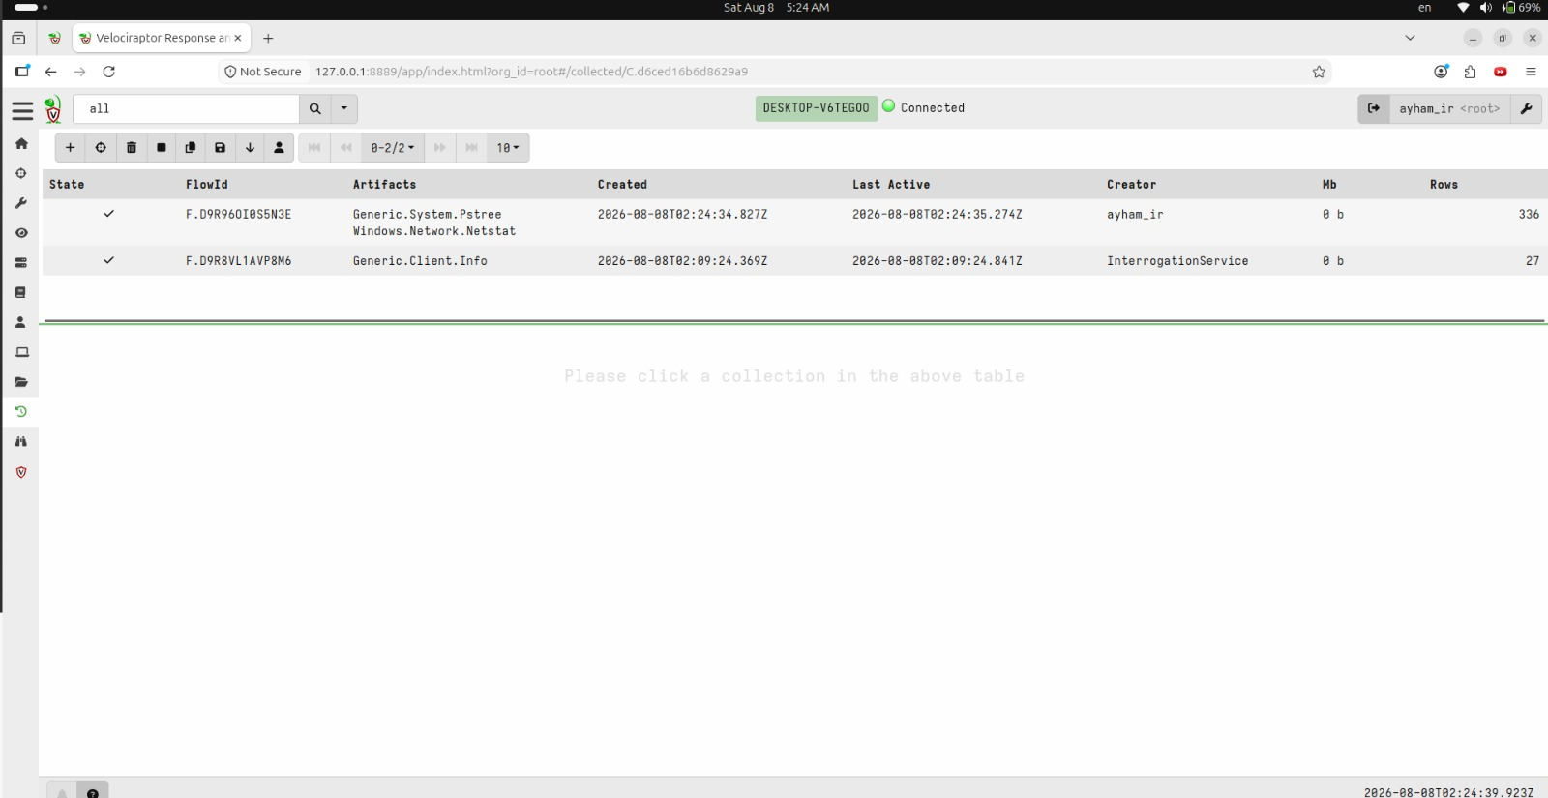
Figure 4. Completed remote collection containing process-tree and network artifacts.
The containment was made to be very limited on purpose. The temporary rules only applied to the two documentation addresses. We still had access to the local network, domain name system, gateway, loopback, Velociraptor and the Internet. The project got rid of its own rules and made sure everything went back, to how it was before.

Control | Result
Safe incident generation | PASS
Pre-containment volatile collection | PASS
Targeted containment | PASS
Post-containment collection | PASS
Rollback | PASS

5. Log Detection and Timeline Correlation
Splunk Search Processing Language was used to extract source addresses, count events, and calculate first and last observation times [4]. The threshold query returned 12 simulated failed logins from 198.51.100.77.

index=ir_lab ("Failed password" OR "event=failed_login")
| rex field=_raw "(?:from\s+|src_ip=)(?<src_ip>\d{1,3}(?:\.\d{1,3}){3})"
| stats count earliest(_time) as first_seen latest(_time) as last_seen by src_ip
| where count >= 5
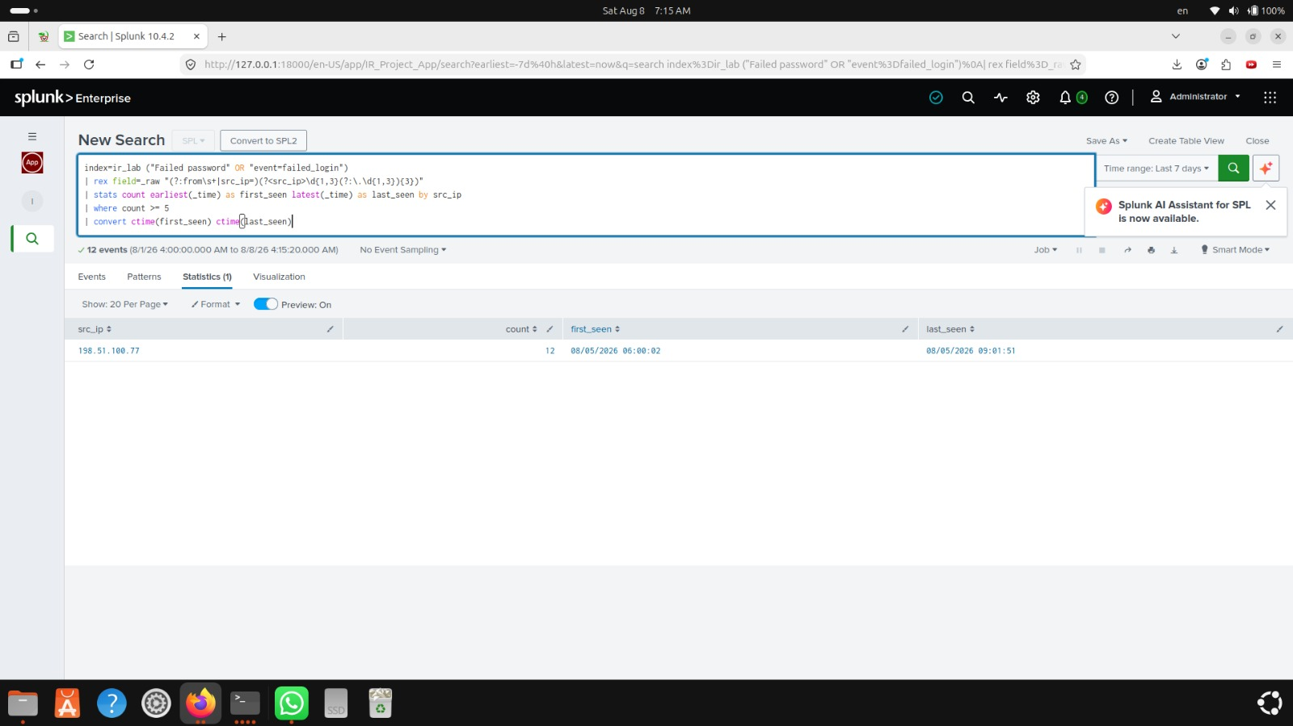
Figure 5. Splunk threshold search identifying 12 simulated failed logins from one source.
Timesketch accepted the generated CSV using the documented JSON/CSV import workflow [5]. Time values were normalized to UTC. The completed sketch contained 4,210 events, including 99 events with the safe-simulation tag.
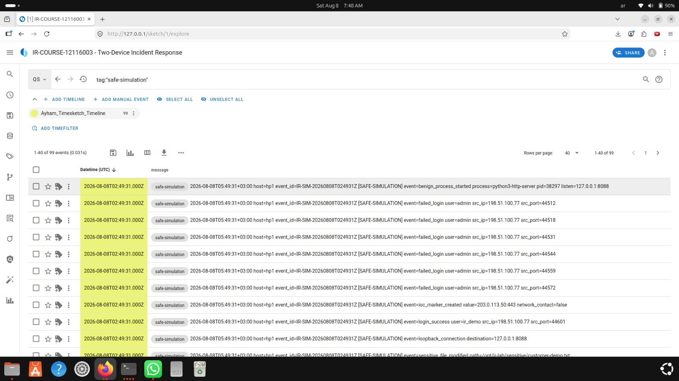
Figure 6. Timesketch query isolating the 99 labelled safe-simulation events.
Why both tools were used: Splunk answered detection and counting questions. Timesketch answered sequence questions. Using both made it easier to explain what happened and when it happened.

6. Memory Acquisition and Analysis
Windows memory was acquired with the signed Go WinPmem tool from the official WinPmem project [7]. The script recorded the tool hash, command, UTC completion time, image size, and SHA-256 digest. Windows security controls were not disabled.

Memory item | Observed value
Image | windows-memory-DESKTOP-V6TEGOO-20260808T050016Z.raw
Size | Approximately 11 GiB
Capture duration | 1 minute 19 seconds
Image SHA-256 | 372de372dddaeb92dc9d4d2f8121cda0280abc4c325cf57358b969657ede98f2

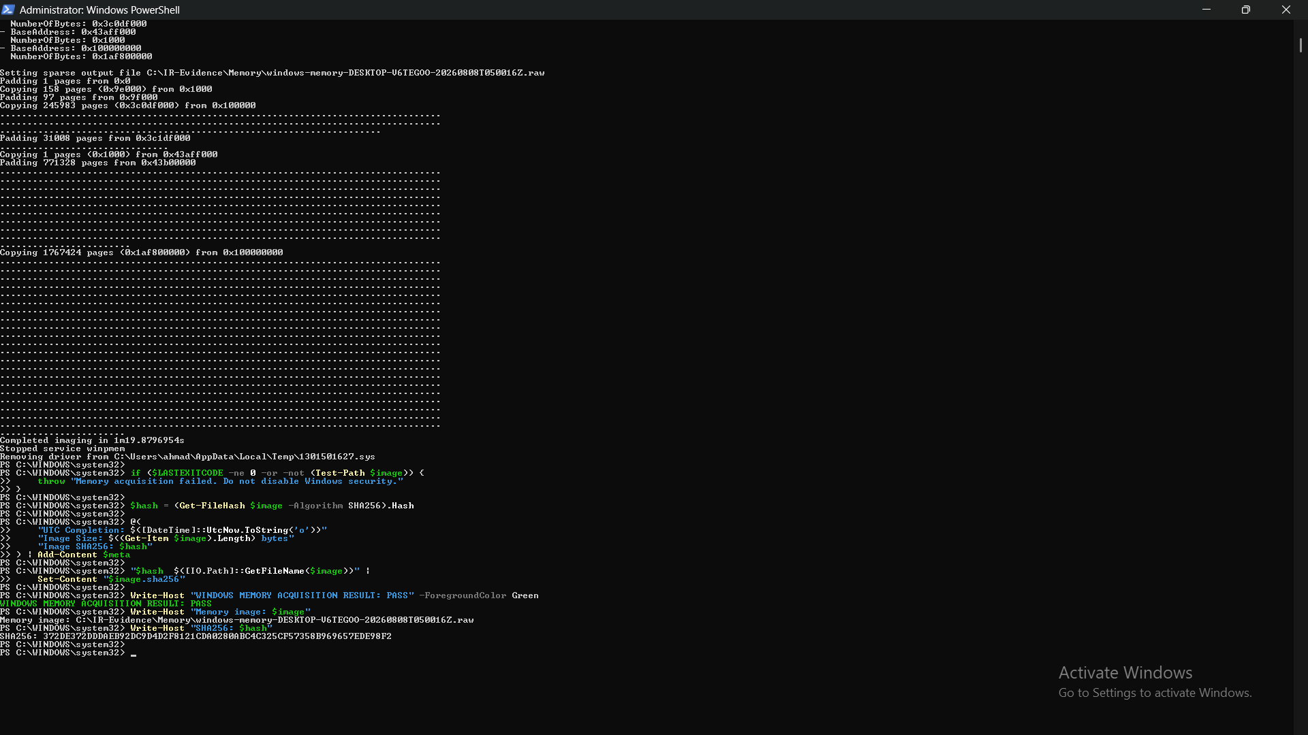
Figure 7. WinPmem completed the raw memory acquisition and produced integrity metadata.
The image, its hash file, and metadata were transferred by SCP to Ubuntu. Ubuntu recalculated the hash over the complete file. The Windows and Ubuntu values matched, so analysis used the verified copy.
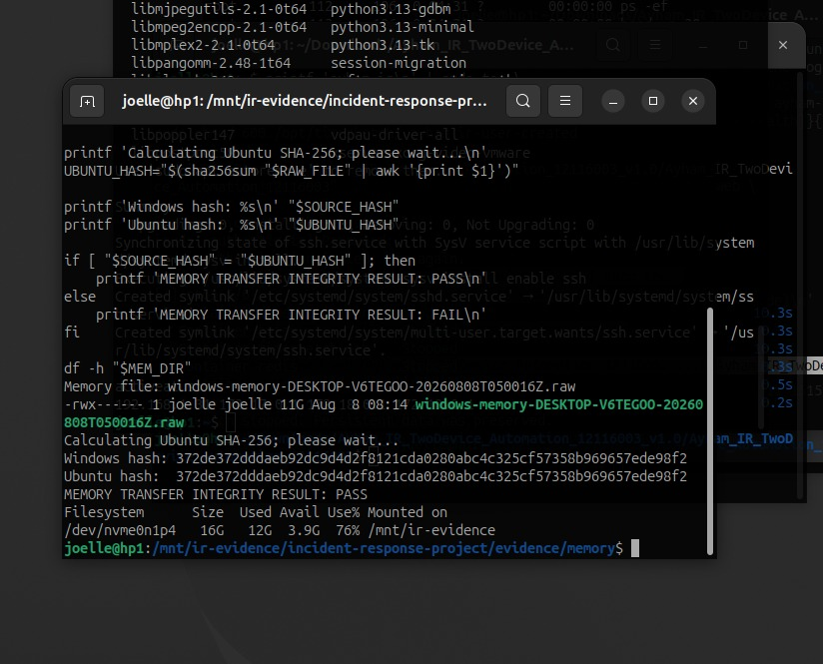
Figure 8. Matching Windows and Ubuntu SHA-256 values after the 11 GiB transfer.
Volatility 3 was then used by following the instructions, in its documented plugin framework [6]. Seven outputs were. Put into a result manifest.

Plugin | Question answered | Validated output
windows.info | What operating system and kernel were captured? | 24 lines
windows.pslist | Which processes were present? | 273 lines
windows.pstree | What were the parent-child relationships? | 273 lines
windows.cmdline | How were processes started? | 273 lines
windows.netscan | Which network artifacts were present? | 4 lines
windows.filescan | Which file objects were in memory? | 10,674 lines
windows.malfind | Which memory regions require review? | 3,383 lines

Analyst warning: A malfind result is an issue, not evidence of bad software. It needs to be checked with information about the process the file location what is, in memory and network activity.

7. IOC, Disk, and Recovery Validation
The IOC workflow took information from the evidence added where it came from and made a STIX 2.1 bundle using the rules from OASIS specification [8]. When we were done with the safe case we had 1,716 candidates that we looked at and 1,716 STIX indicators. The IOC workflow and STIX 2.1 bundle are just tools to help with the investigation. These STIX indicators and IOC workflow records are notes, from the investigation not saying that every single value is bad. The STIX 2.1 bundle and IOC workflow are important for the investigation records.

Area | Test | Result
IOC handling | Register and STIX 2.1 bundle | PASS
Disk forensics | Disposable raw image | PASS
Deleted-file recovery | Recover known token | RECOVERED_AND_CONTENT_VALIDATED
Backup integrity | Detect deliberately corrupted copy | PASS
Recovery | Restore clean archive in isolation | PASS
Recovery integrity | Compare restored manifest | PASS

The recovery test is really important for business use. A backup is not good enough just because it is there. For the workflow to work properly we need to be able to detect if something's wrong with the backup restore it without any problems and make sure all the files are exactly the same as they were before. The recovery test is crucial for business use because it helps us make sure that our backups are reliable and that we can get our files back if something goes wrong. We need the recovery test to check for corruption do a restore and have a matching file list, for the workflow.

8. Evidence Integrity and Reproducibility
Each major phase created a directory that had a time stamp. The raw evidence and the analysis results were kept apart. Important files got SHA-256 sidecars or manifests. Transfers were checked at both ends. The finalization script made a summary, an evidence manifest and a submission archive.

Evidence control | Implementation
Time | UTC timestamps and synchronized systems
Storage | Dedicated evidence root on Ubuntu
Integrity | SHA-256 for exports, images, transfers, and archives
Traceability | Command logs, case IDs, source paths, and manifests
Privacy | Raw memory, secrets, and generated private configuration excluded
Reproduction | One command interface plus a complete code and stage guide

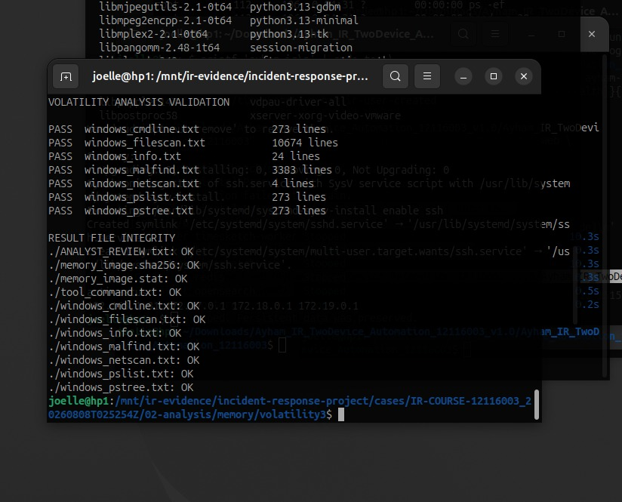
Figure 9. Volatility validation showing all result files and sidecars as OK.
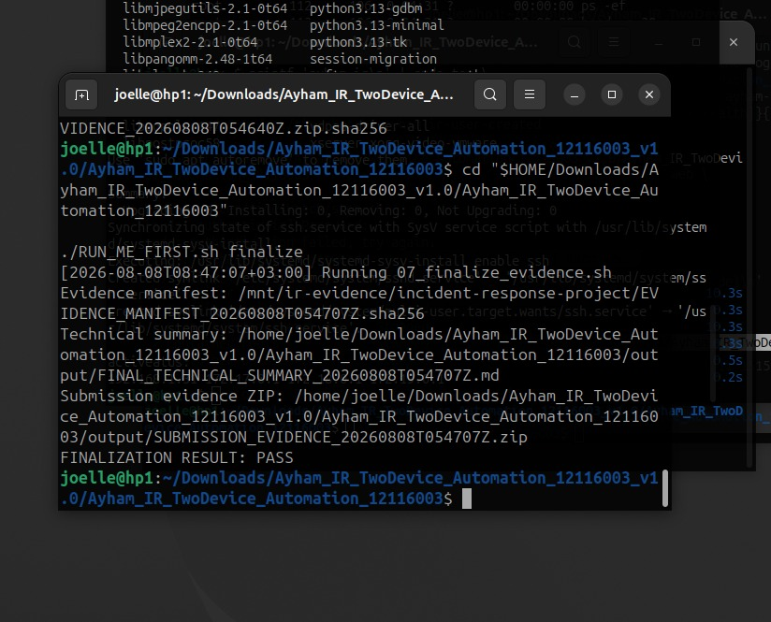
Figure 10. Final evidence manifest, summary, and submission archive created successfully.

9. Troubleshooting and Engineering Decisions
Issue | Decision and outcome
Ubuntu root partition reached 93% | Measured usage, removed targeted downloads, and restored safe free space before services.
NTFS USB dirty flag | Repaired the filesystem with Windows chkdsk, removed it safely, and verified copied hashes.
Splunk initialization delay | Checked service state, logs, and HTTP response instead of repeatedly rebuilding the container.
Timesketch 502 response | Verified backend processes, restarted nginx, and confirmed HTTP 302 before creating the user.
Large CSV field | Raised Python's field limit and capped source references to keep timeline generation reliable.
Memory tool command mismatch | Added signed Go WinPmem support and recorded the exact acquisition mode.
Limited analyst resources | Ran Splunk and Timesketch separately and preserved persistent volumes.

Engineering lesson: A professional lab is not only a successful final screen. It also records failures, limits the scope of each fix, and rechecks the result.

10. Findings, Limitations, and Business Use

Main findings
• The Windows endpoint stayed visible and returned process and network evidence remotely.
• The safe scenario was observable in Linux logs, Splunk, Velociraptor, and Timesketch.
• Containment and rollback worked without isolating normal network services.
• The memory image remained unchanged across the Windows-to-Ubuntu transfer.
• Memory, disk, and recovery outputs passed their documented validation checks.
• The final package can be reviewed without exposing raw memory or credentials.

Limitations
• The incident is synthetic and cannot support attribution to a real threat actor.
• Memory acquisition changes system state and may capture personal data.
• IOC and malfind candidates require analyst review and corroboration.
• The lab uses a small network and does not represent enterprise scale or high availability.
• Screenshots prove the completed case but do not replace access control, retention, and legal procedures used in a company.

Business use
A small organization could adapt this design as a training and validation environment. The strongest reusable parts are the evidence directory structure, hash checks, endpoint collection, reversible containment, timeline workflow, and recovery test. A production deployment would still need role-based access, centralized identity, formal retention, alert ownership, legal approval, and tested escalation procedures.

11. Conclusion
The project meets the ten-skill course requirement through one connected incident response case instead of ten unrelated demonstrations. It combines endpoint collection, log detection, safe containment, timeline correlation, memory and disk forensics, IOC handling, and recovery validation.
Its main strength is evidence continuity. Collection comes before containment when practical. Important files are hashed. Transfers are verified. Findings are labelled with their limits. Recovery is tested rather than assumed. This makes the project suitable for academic review and useful as a defensive security portfolio example.

Final status: is that we have verified ten skills. We also finished the workflow that used two devices. When it comes to finalizing the evidence everything is okay it is a PASS. We verified ten skills. That is done.

References
[1] NIST SP 800-61 Rev. 3 — Incident Response Recommendations and Considerations for Cybersecurity Risk Management. DOI: 10.6028/NIST.SP.800-61r3. https://csrc.nist.gov/pubs/sp/800/61/r3/final
[2] NIST SP 800-86 — Guide to Integrating Forensic Techniques into Incident Response. DOI: 10.6028/NIST.SP.800-86. https://csrc.nist.gov/pubs/sp/800/86/final
[3] Velociraptor Documentation. https://docs.velociraptor.app/docs/
[4] Splunk Enterprise 10.0 Search Manual — About the Search Language. https://help.splunk.com/en/splunk-enterprise/search/search-manual/10.0/search-overview/about-the-search-language
[5] Timesketch User Guide — Import from JSON or CSV. https://timesketch.org/guides/user/import-from-json-csv/
[6] Volatility 3 Documentation. https://volatility3.readthedocs.io/en/latest/
[7] Velocidex WinPmem — Official Repository. https://github.com/Velocidex/WinPmem
[8] OASIS STIX Version 2.1 Specification. https://docs.oasis-open.org/cti/stix/v2.1/os/stix-v2.1-os.html
[9] RFC 5737 — IPv4 Address Blocks Reserved for Documentation. https://www.rfc-editor.org/rfc/rfc5737.html
[10] Course Cybersecurity Skills Repository — Pinned Commit. https://github.com/mukul975/Anthropic-Cybersecurity-Skills/commit/2fb6a9faff42977f9e64b1f0dcb97bb2a1e67267

Companion files
The README provides an overview of the GitHub. Ayham_IR_All_Code_and_Stages_12116003.md has the step-, by-step implementation and all the source code. The source ZIP file includes the project files that're safe for privacy. The SHA256SUMS.txt file keeps track of the delivery hashes.

